**Data Testing Assessment**

|  |  |  |  |  |
| --- | --- | --- | --- | --- |
| Student Name | StudentRollNo | Class | Age | Father's Name |
| AJAY KUMAR | IETLINF01 | X | 16 | PREM KUMAR |
| RAJAT MISHRA | IETLINF02 | XI | 17 | PANKAJ MISHRA |
| SUDHEER SHARMA | IETLINF03 | IX | 15 | SUNDER SHARMA |
| NANCY KAUR | IETLINF04 | XII | 18 | AK SINGH |
| SUMITA SHARMA | IETLINF05 | IV | 14 | AJAY SHARMA |
| NANDINI GUPTA | IETLINF06 | VII | 18 | RAM GUPTA |
| RAM KUMAR | IETLINF07 | X | 16 | RAMAN KUMAR |

Tasks

1. Write sql query to find out total number of students in each class.
2. Write sql query to find out average age of students in each class.
3. Write sql query to find out the number of students having same roll no.
4. Write sql query to view the duplicate name of a student from the table.

1.Create above table in database and insert the data.

Create table students_table(Student_Name varchar2(20),Student_Roll_No varchar(20),Class varchar2(3),Age number(2),Father_Name varchar2(20),CONSTRAINT PK_student Primary key (Student_Roll_No));

select * from students_table;

Insert into students_table Values ('AJAY KUMAR','IETLINF01','X',16,'PREM KUMAR');

Insert into students_table Values ('RAJAT MISHRA','IETLINF02','XI',17,'PANKAJ MISHRA');

Insert into students_table Values ('SUDHEER SHARMA','IETLINF03','IX',15,'SUNDER SHARMA');

Insert into students_table Values ('NANCY KAUR','IETLINF04','XII',18,'AK SINGH');

Insert into students_table Values ('SUMITA SHARMA','IETLINF05','IV',14,'AJAY SHARMA');

Insert into students_table Values ('NANDINI GUPTA','IETLINF06','VII',18,'RAM GUPTA');

Insert into students_table Values ('RAM KUMAR','IETLINF07','X',16,'RAMAN KUMAR');

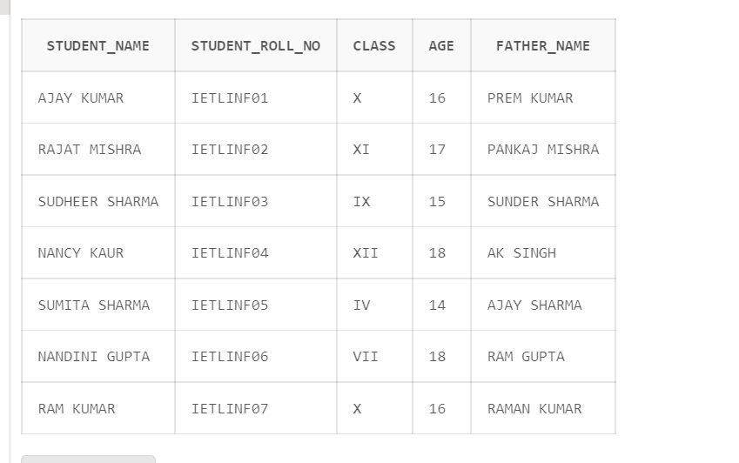

2. Write sql query to find out total number of students in each class.

select class,count(Student_Roll_No) as StudentCount from students_table GROUP BY class ORDER BY StudentCount;

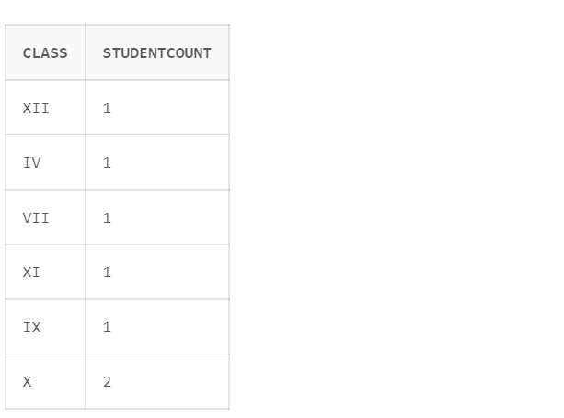

3. Write sql query to find out average age of students in each class.

select Class,AVG(Age) as Avg_Age from Students_table GROUP BY Class;

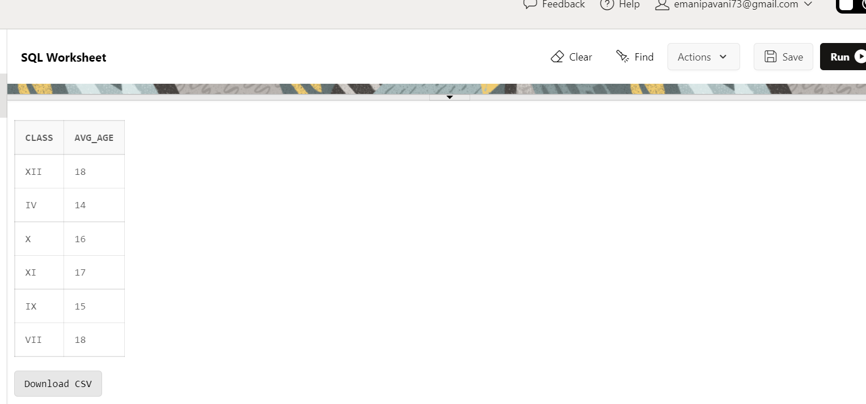  
4. Write sql query to find out the number of students having same roll no.

SELECT COUNT(Student_Roll_No) from Students_table GROUP BY Student_Roll_No HAVING COUNT(Student_Roll_No) > 1 ;

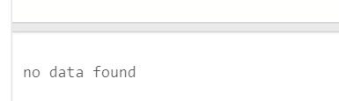

5. Write sql query to view the duplicate name of a student from the table.

select Student_Name from Students_table GROUP BY Student_Name HAVING COUNT(*)>1;



Added a duplicate Name

Insert into students_table Values ('AJAY KUMAR','IETLINF08','1X',14,'KUMAR');

select * from Students_table;

